Name: Bea C. Infanso Date: 04/24/26
Course & Yr.: BSIT 3A Score:

Activity Title:
Building and Integrating a Laravel Application with APIs

Submission Requirements
- Screenshots:
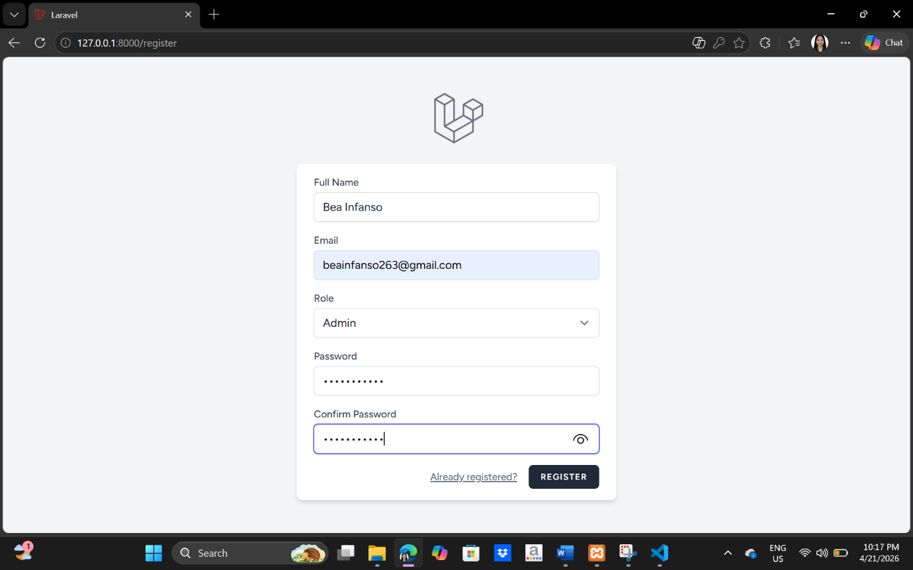
  - Login/Register

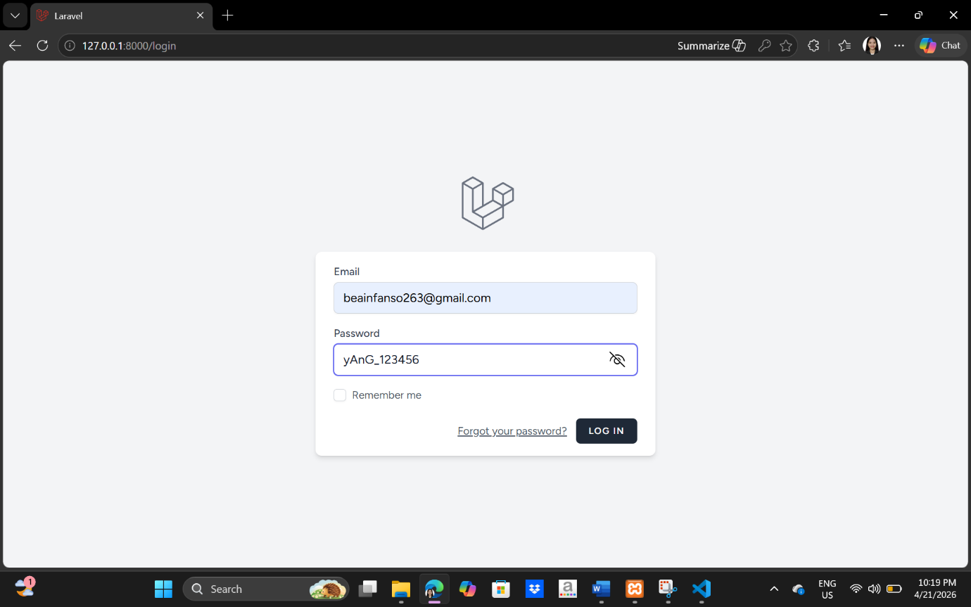

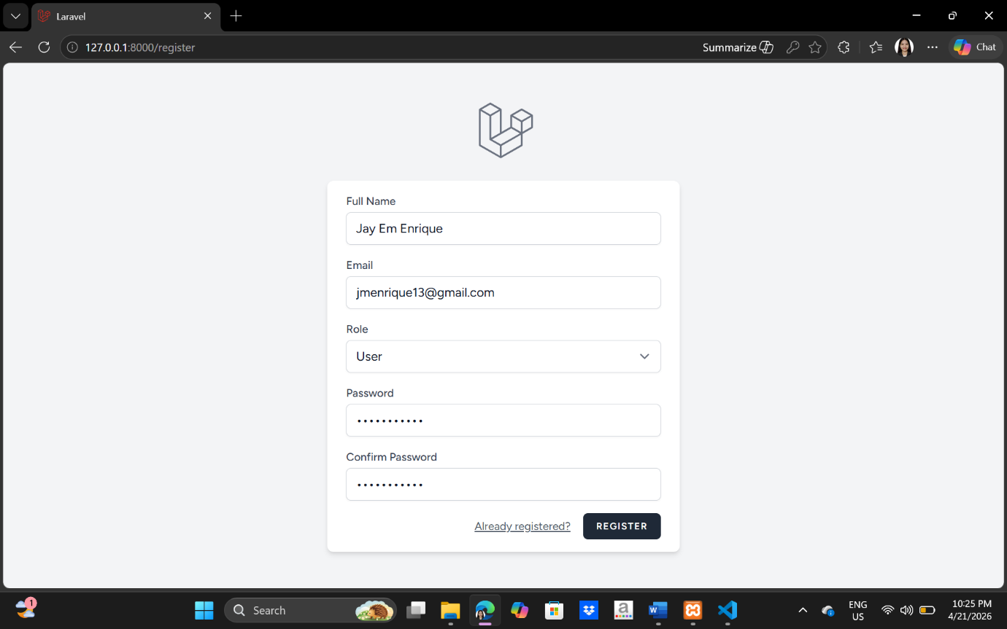

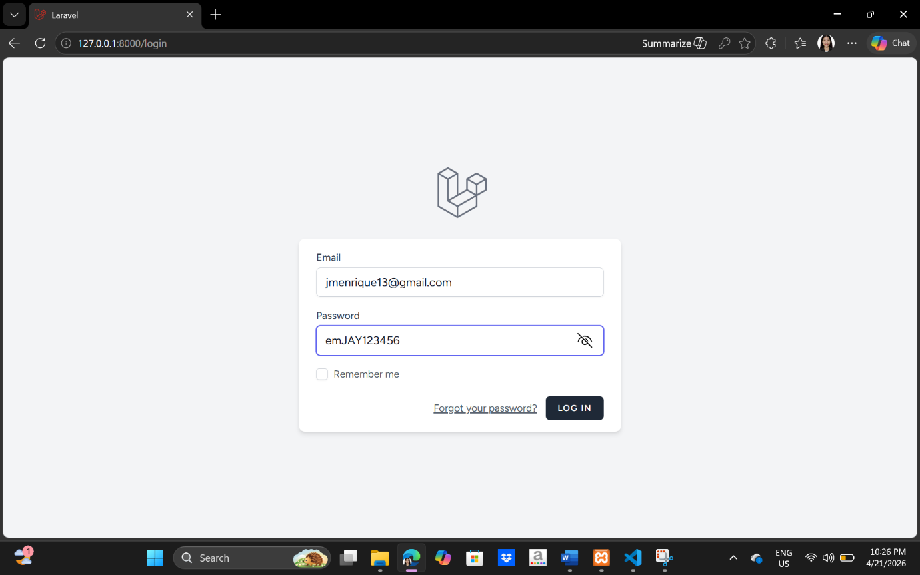

  - Dashboard
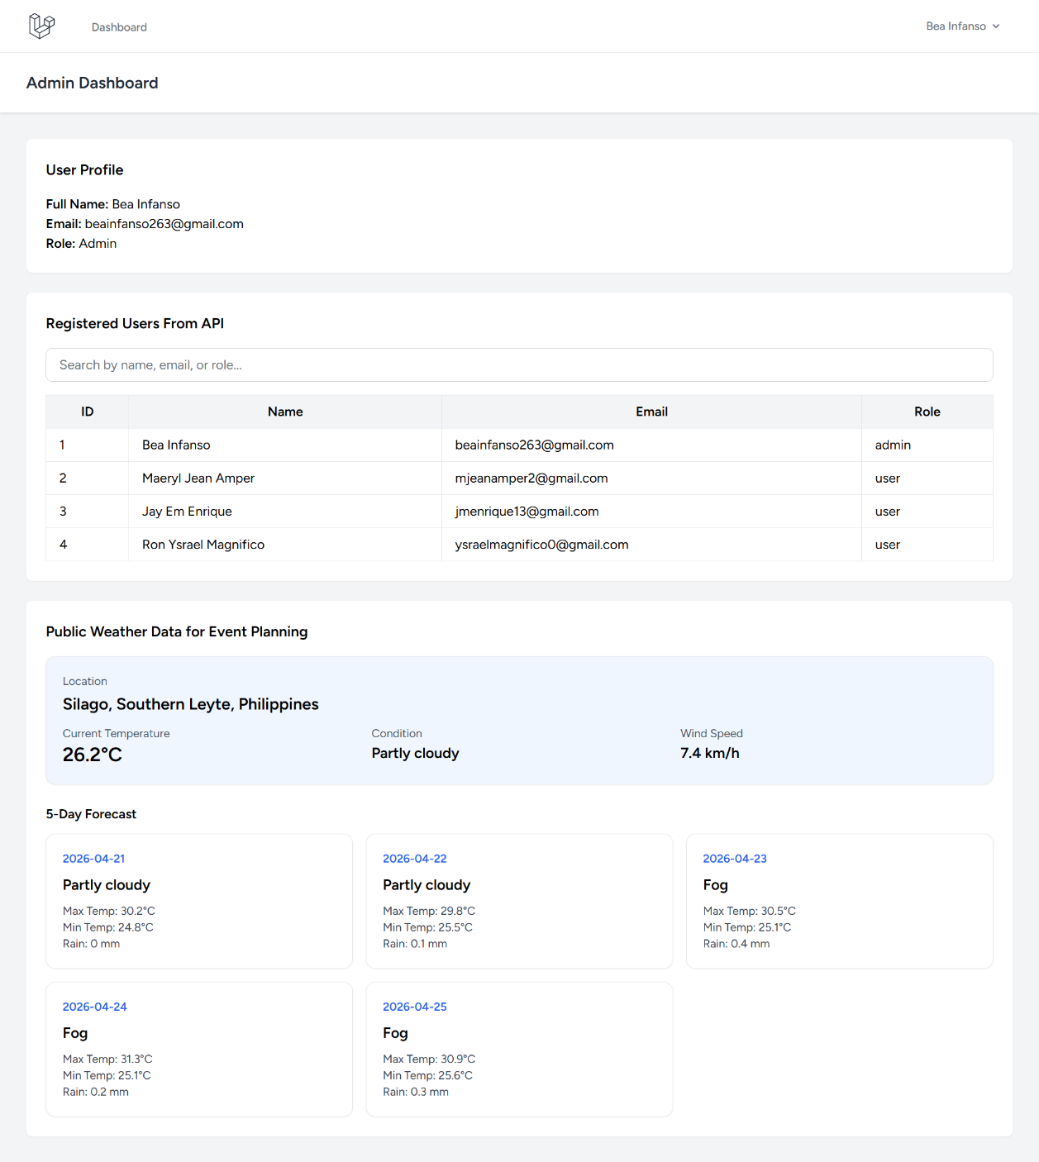

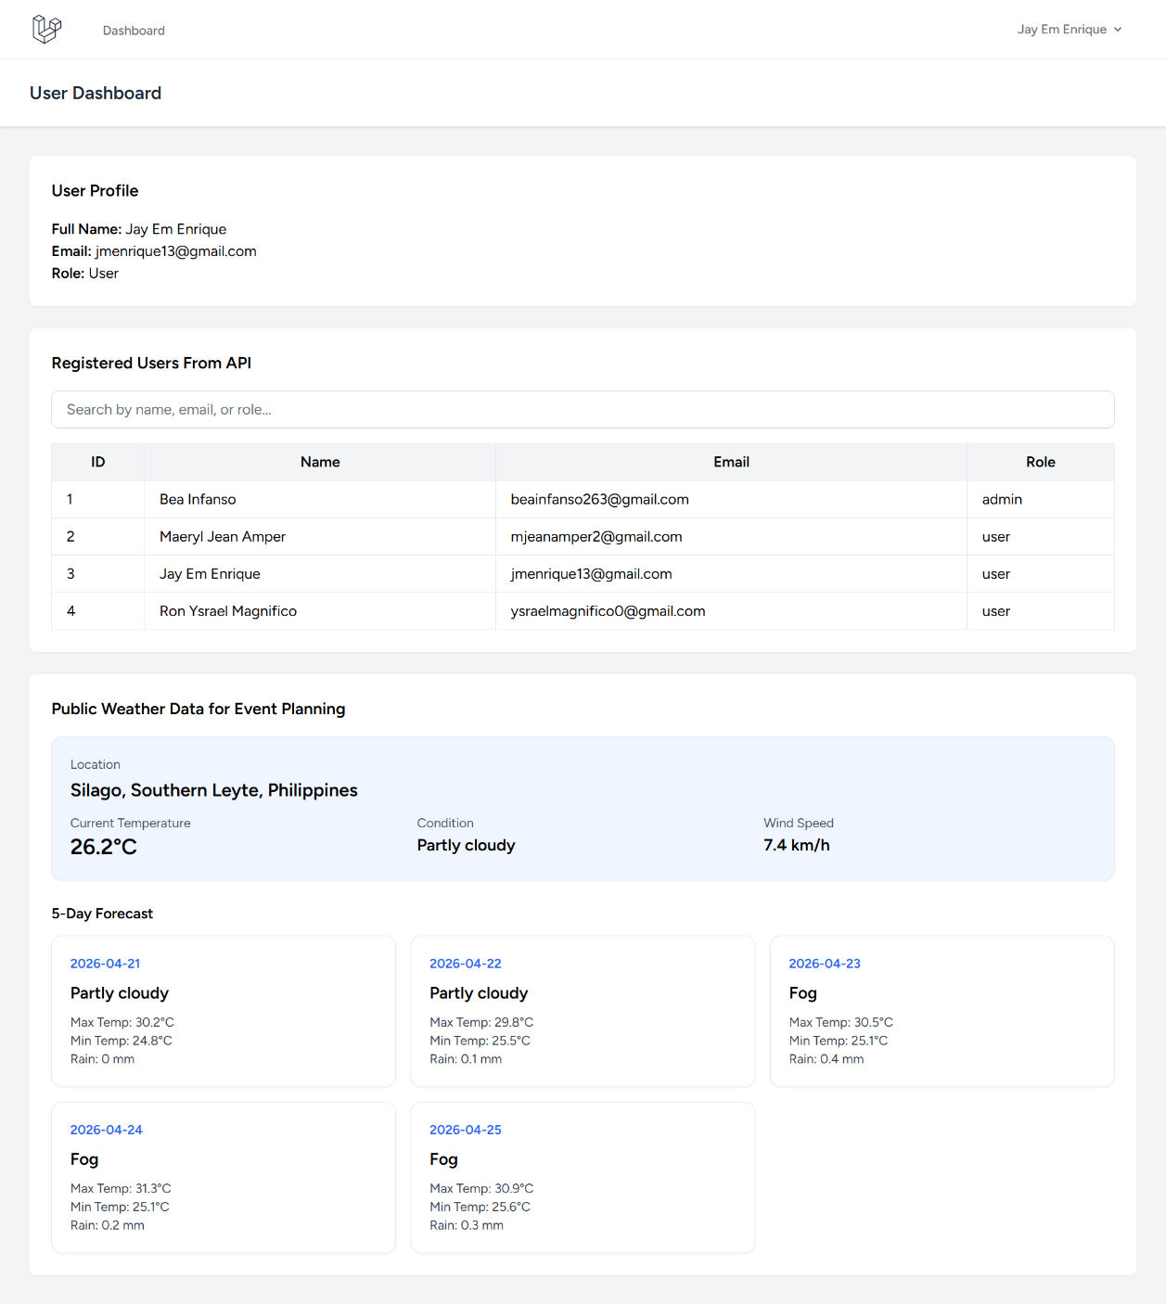

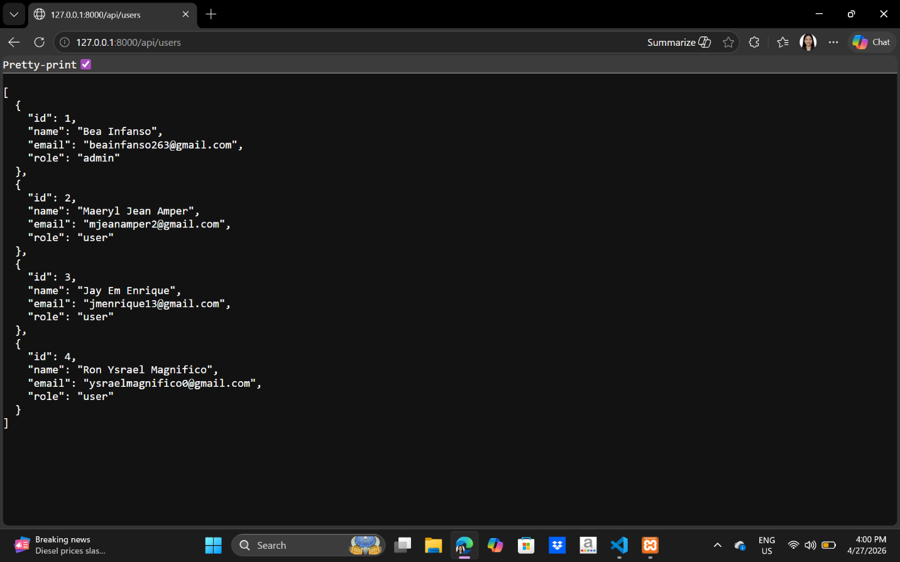
  - API output

- Short documentation
  - System description
The Event Dashboard is a simple web application developed using Laravel to demonstrate basic system integration concepts. The system uses Laravel Breeze for user authentication, allowing users to register, log in, and access the dashboard based on their assigned role, such as admin or user. After login, the dashboard displays the logged-in user’s profile information, including full name, email, and role. This setup satisfies the activity requirement of using authentication and showing logged-in user information in the system. The dashboard also integrates data from the system’s own API and from a public API. A custom Laravel API endpoint, /api/users, was created to return the list of registered users in JSON format. This data is displayed in the dashboard under the registered users section. In addition, the system consumes weather data from a public API and presents the current weather condition, temperature, wind speed, and a 5-day forecast for Silago, Southern Leyte, Philippines. This weather section supports event planning because weather conditions are important in scheduling and preparing for activities, especially outdoor events. The dashboard also includes a search and filter feature in the users table to improve usability and meet the bonus challenge for search functionality.
  - APIs used
The project used two APIs. The first API is a custom Laravel API created within the system. This endpoint is located at /api/users and is responsible for returning the registered users’ data in JSON format. It was used to display the list of users directly on the dashboard. This part satisfied the requirement of creating and using the system’s own API.
The second API used in the project is the Open-Meteo public API. This API provided live weather information such as current temperature, weather condition, wind speed, and 5-day forecast data. The public weather data was displayed in the dashboard under the weather section for event planning. This satisfied the requirement of consuming and displaying data from a public API.

  - Challenges encountered
Several challenges were encountered during the development of the system. One challenge was configuring Laravel Breeze, since the installation required selecting the proper setup and completing authentication features before continuing with the dashboard. Another challenge was modifying the registration process to include a role field and implementing role-based dashboard redirection for admin and user accounts. This required updating the migration file, user model, registration form, and authentication logic.
Another issue encountered was the missing profile.edit route after modifying the web routes. This caused an error in the dashboard and was resolved by restoring the missing profile routes required by Laravel Breeze. There was also a problem where the users table initially failed to load data from the custom API even though the endpoint itself was working. This was fixed by checking the API output, updating the JavaScript fetch logic, and refreshing the browser after saving the changes. Lastly, the first public API used in the project displayed placeholder text that was not suitable for an Event Dashboard, so it was replaced with weather forecast data to make the application more useful, readable, and relevant to the system’s purpose.

